

Smart Masjid

Project Requirements

Prepared by
Mudassir Ahmed

Project Overview
The goal of the smart IoT speaker is to connect organizations that stream audio to their subscribers. Below are the steps identified in the workflow of the project.
- The organization would register with us, and we will provide them with Audio Encoder and Smart IoT button.
- The organization admin would then setup stream schedules using our web application.
- The subscribers would purchase speakers from us and connect their speaker via our mobile app and subscribe to organization of their choice.
- Once they have subscribed to the organization, they can subscribe to various streams offered by the organization.
- The organization will trigger an event from the smart IoT button provided by us when they want to start streaming.
- The speaker will receive the event and start streaming the audio from the media server.

Architecture

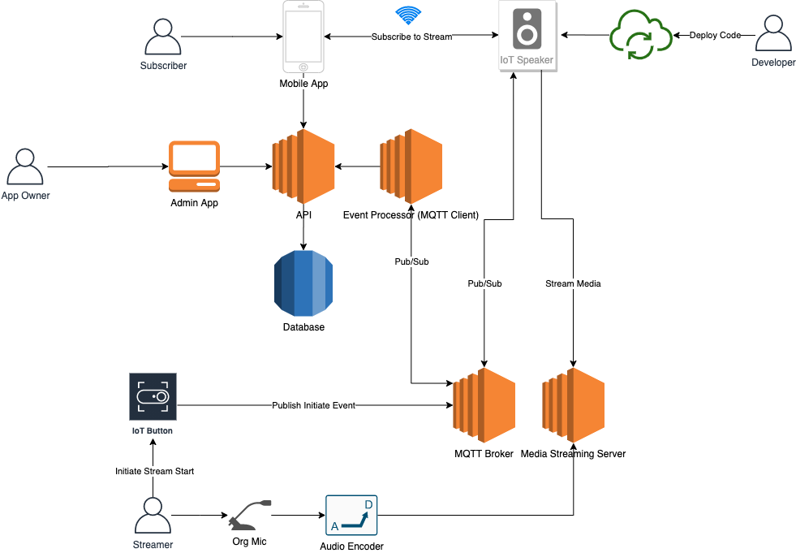

Components
Given below is the breakdown of the requirements based on the various components involved in this IoT speaker project.

MQTT Broker
- A secure MQTT broker setup to publish and subscribe events which in our case is AWS IoT Core.

IoT Speaker

Hardware Requirements:
  - ESP32 microcontroller
  - 3w speaker
  - Battery powered
  - LED light
    - Yellow blinking when not connected to WiFi
    - Green when connected to WiFi
    - Red when low battery
    - Green blinking when streaming
  - Power button
    - Turn on/off speaker
  - Volume up button
  - Volume down button
  - Mute button (Done)
    - Mute audio while streaming. Unmute after streaming is done.
  - Reset device(Done)

Firmware Requirements:
  - Ability to consume MQTT events
  - Play audio at good quality from streaming url
  - Device discoverability module via Wifi Access Point
    - Discover Device
    - Pass Wifi credentials
  - Publish new device message
  - Ability to connect to WiFi
  - Animation for RGB LED ring
  - Ability to deploy firmware updates over the air (OTA) via APIs on the device
  - Send Telemetry
    - Connection Status
    - Battery life

Cost Requirements
  - Mass production should cost not more than 5 $ per speaker

Miscellaneous Requirements
  - Size between 3.5 to 6 inches
  - Logo print

Mobile App
- Module to detect and connect to the speaker and pass WiFi credentials to it
- Module to subscribe the speaker to a MQTT events
- Module to delete subscriptions of an MQTT events from the speaker
- Module to reset the speaker
- Module to update wifi credentials

IoT Button
- ESP 32 microcontroller
- WiFi enabled button with LED
- Button function
  - LED starts blinking when pressed first time
    - Sends adhan/start MQTT event
  - LED stops blinking when pressed second time or if 5 minutes have passed after first press.
    - Sends adhan/stop MQTT event
- Animation for RGB LED ring
- Physical Requirements
  - Not more than 5 inches
  - Logo print
  - Ability to screw on the wall

Event Processor

Functional Requirements
- The core function of the MQTT client will receive messages from the IoT button and process them to determine if adhan event needs to be triggered or not. There are two primary functions of the client. In addition, there is also a device telemetry function.

- New Device
  - TBD - Nauman
- Adhan Start:
  - Listens to adhan/start sent by the IoT Button which is in the below format
topic: adhan/start
{
masjidId: 1
}
  - Determines what adhan time is it right now for masjid id 1
  - Sends a message in the below format
masjid/1/adhan/fajr
{
action: "START"
streamUrl: https://192.184.99.10/**
}
  - Devices subscribed to the above topic will recieve it via IoT core and start streaming from the url

- Adhan Stop:
  - Listens to adhan/stop sent by the IoT Button sent in below format
topic: adhan/stop
{
masjidId: 1
}
- Determines what adhan time is being streamed currently for masjid id 1
- Sends a message
topic: masjid/1/adhan/fajr
{
action: "STOP"
streamUrl: https://192.184.99.10/**
}
  - Devices subscribed to the above topic will recieve it via IoT core and stop streaming from the url
- Device Telemetry:
  - Listens to device telemetry event sent by the device in below format
Topic: device/telemetry
{
macAddress: XXXXXXX
status: ONLINE/OFFLINE
battery: 50
}
- Saves the device telemetry in the DB by calling the API.

API:
- The API will act as a backend for the mobile app and the web application.
- Auth Endpoints:
  - Login user using phone number
    - Send OTP
    - Verify OTP
  - Create account
    - Add account
    - Update account
  - Logout
- Masjid Endpoints
  - List masjids based on location/zip code
  - Fetch masjid details
  - Subscribe to masjid
  - Unsubscribe to masjid
  - Get Adhan timings
  - Get Iqama timings
  - Check adhan time
  - Save Adhan Time
  - Update Iqama Time
- Device Endpoints
  - List devices
  - Fetch device details
  - Add wifi network
  - Update wifi network
  - Update wifi password
  - Reset device
- Admin Endpoints
  - Add/Update Adhan Config
  - Update Iqamah Time

Process Flows:

Process Flow Diagrams

